Service | Types | Example Use | Benefits
1. Communication | - Email  - Messaging  - News groups  - Social networks  - Conferencing  - Blogs  - Vlogs | 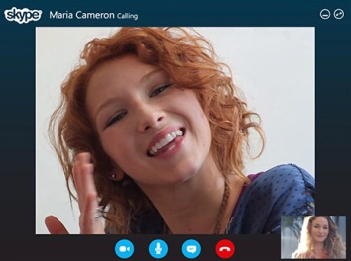  Skype.  Video call, messenger, conferencing software. | Free to use software. Uses your internet connection so you don’t have to pay for calling and you can now use it on your phone also (if you got android or ios). Also you can call multiple people in conversation and do video chat with multiple people if you buy Skype premium.
2. Real-time  information | - Timetables  - News  - Sports updates  - Weather reports  - Travel news | Sky Sports News Phone app. The information is refreshed frequently usually seconds after a goal.   | Sky Sports news mobile app allows you to view all the latest sports statistics and news on your phone updated in real time if you have internet access. It is good if you can’t go watch a football match for example and want to know what the scores are while it’s happening.
3. Commerce | - Banking  - Auctions  - Online sales and purchases  - Publishing | Banks store your money and help you pay for things online. They also give you loans.   | Free to make a bank account and get good service from it. Can pay for things online for example your internet bills. You can use your credit card for online shopping. The banks allow you to get loans.
4. Government | - Tax returns  - E-voting  - Applications for grants or benefits | 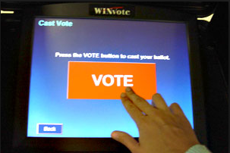 E-Voting. | E-voting is a way of voting for anything without having to fill in a form or worrying about handing it in just do it on your computer or e-vote machine. You don’t have to wait in a queue to vote and it is counted faster by a computer instead of being counted individually from the voting sheets.
5. Education | - Online learning  - Online training  - Manufacturers’ online tutorials | MyMaths.com (online homework) | A website used for maths revision or doing online homework. Means you don’t have to bring in homework or doesn’t matter if you lose it because you can log on and complete it on your pc. You can do your homework at home or anywhere if you have a computer with internet access.

Service | Types | Example Use | Benefits
6. Virtual learning  environment (VLE) | - VLEs such as Moodle | 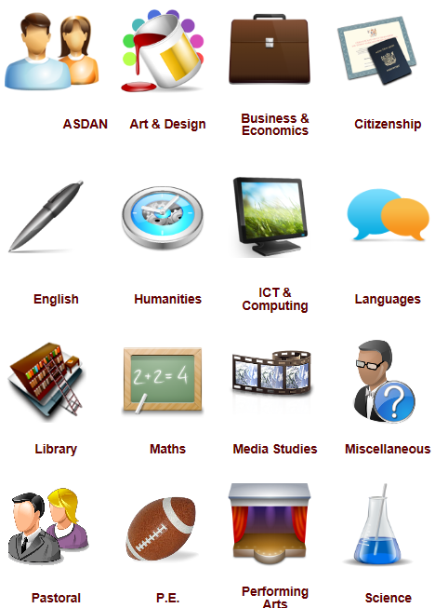 | Our school Moodle is a great way to upload work and access resources required to complete work. Every student and teacher have their unique individual login and password so their work is protected and can only be accessed by the individual student and the teachers also. Provides fast and easy access.
7. Business  (different types  of organisations) | - Business networks,  - Collaborative working  - Video conferencing | Paying Online | A great way of paying online without having to fill in any personal details on other websites just logging in with your PayPal account.
8. Entertainment | - Multi-user games  - Radio and TV players  - video streaming |  twitch.tv | Twitch.tv is a website used to stream video games and watched by hundreds of thousands of people too sees how the professional gamers play and enjoy the casual gamers entertaining live streams. The advantage of live streams over tv is that you can watch it on the move from your phone tablet or on your personal computer if you have internet.
9. Download  Services | - Music  - Films  - New software  - Software upgrades  - Online games |   For example you could download a game from “Steam” (a game service for pc) to your computer from their file servers. | Can download games instantly instead of using a dvd to install them.

